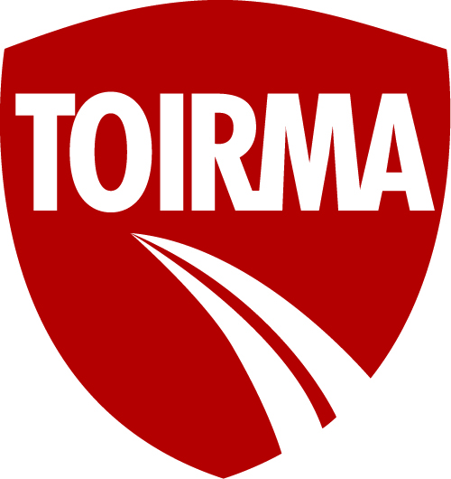
CLAIM FORM
Submit claim form via email or fax to:
Email: toirmaclaims@ccmsi.com Fax: 217-444-2720
Member: County: | Phone#:
Mailing address: | Fax#:
Contact name: Position: | Email:
Date of accident/incident: Time: Location:
Description:
Name of state agency/authorities responded: Report#:
CLAIM TYPE
☐ Auto – licensed Township vehicle.
List Year/Make/Model/Vin#.
☐ Inland Marine – Mobile equipment/portable tools.
List Year/Make/Model/Vin#.
☐ Property – Building/Property in the Open.
List building name (as listed on property schedule) and physical address.
Cause & Description of Damage:

Complete this section if accident/incident involved another party:
TOWNSHIP DRIVER INFORMATION:
Township driver’s name: Phone#:
Seatbelt? Y or N List any passengers in Township vehicle:
Any injuries? Citations issued?
OTHER PARTY’S INFORMATION:

Name: Phone#:
Address: Year, Make & Model:
Any injuries? Citations issued?
Description of damage: Drivable? Y or N
Passenger(s) Names/Phone#s:
WITNESS INFORMATION:

Names & Phone#s:
Additional information/comments:

REPORT COMPLETED BY:
Name: Title: | Phone#:
A TOIRMA Claim Representative will contact you within 24-48 business hours after submission of this Claim Form. For immediate assistance, please call 800-252-5059 ext. 1418, ext. 1372, ext. 1263, ext. 1245, ext. 1191, ext. 1349.

